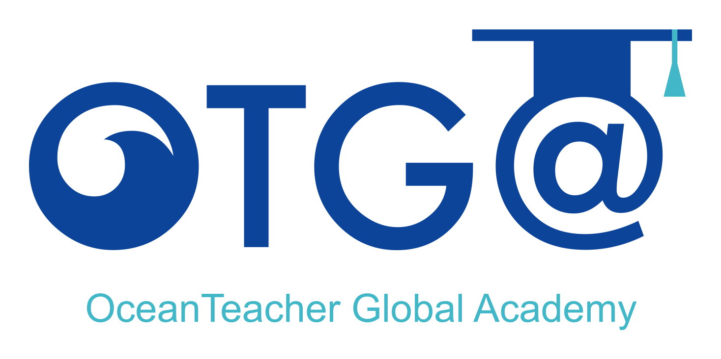

***OceanTeacher Global Academy***

***Training Course***

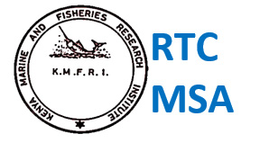

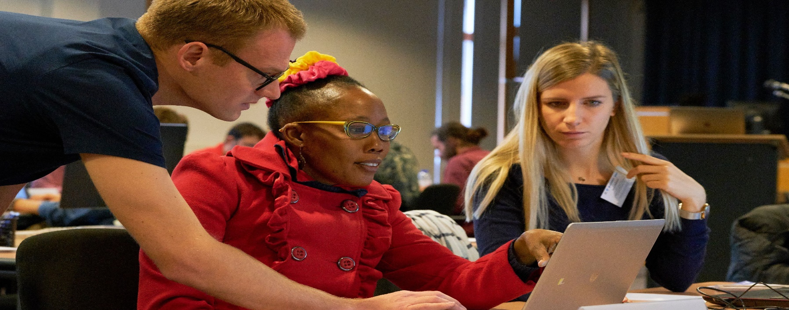

**Course information**

**Duration**

Spread over 3 weeks (25 hours classroom sessions plus pre course preparation assignments)

**Venue**

Virtual - online

**Trainers**

Harrison Ong’anda

Amon Kimeli

Diana Mathai

Victoria Obura

**Period for Applications**

15 October – 15 November 2021

**To apply**

Please fill the **online application** form: https://bit.ly/37kR8vp

**More information** https://www.oceanexpert.net/event/2627

No tuition fee applies.

**Contact**

Further information contact the OTGA Training Coordinator: ioc.training@unesco.org

Useful sites:

* www.oceanteacher.org
* www.oceanexpert.net
* www.ioc-cd.org
* www.iode.org



***The UNESCO/IOC Project Office for IODE is certified as a Learning Services Provider***



***Fundamentals of Ocean Mapping***

***29 November – 17 December 2021***

This course is about the seafloor, its features, properties and tools used to characterize seafloor. The aim is to realize the goals of the UN Decade of Ocean Science for Sustainable Development in supporting especially the three societal outcomes that are critical in ocean mapping namely: A healthy and resilient ocean; A predicted ocean; and A transparent and accessible ocean.

**Learning Outcomes**

After the course participants will have the knowledge, skills and experience to be able to:

* Gain knowledge of the fundamentals of bathymetric survey planning and execution; - including fixed geodetic points vs portable GPS
* Gain skills in processing of bathymetric data and generation of bathymetric maps using CARIS, QGIS
* Understand the difference between single-beam and multi-beam data
* Recognize key bathymetric seafloor geomorphology and water column acoustics
* Generate satellite derived bathymetry for coastal shallow areas
* Be aware of the seabed 2020 seafloor mapping initiatives and obligations
* Gain knowledge of the UNCLOS and governance of the seabed

**Target Audience**

* Marine researchers and postgraduate students (MSc and PhD students);
* Marine research/management institutions;
* University teachers;
* Staff from National Oceanographic Data Centres;
* Freelance consultants

Note: UNESCO is committed to promote equal access principles. Applications from minority or underrepresented groups are strongly encouraged.

**Course Pre-requisites**

Applicants are expected to:

* have an interest or new responsibilities in working with marine bathymetry data and/or information
* have a working knowledge of English

**A Certificate of Participation will be issued to all participants (minimum 90% attendance).**